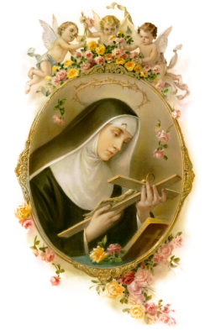 | 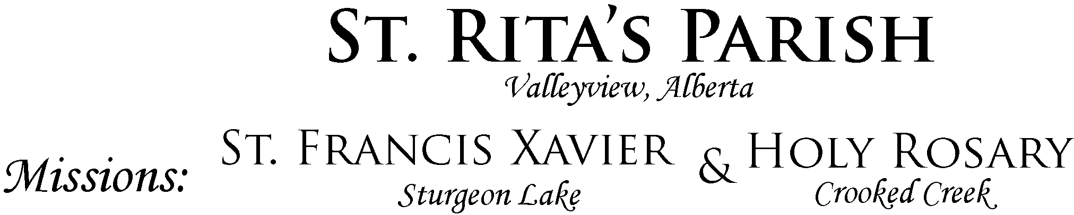  WEEKLY BULLETIN
Sunday Mass SCHEDULE  SATURDAY 7:00 PM  (St. Rita)  SUNDAY  St. Rita 10:00 AM  St. Francis 12:30 PM  Holy Rosary 2:00 PM  WEEKDAYS  Tuesday  7:00PM  Wednesday  [Mass at the Red Willow Lodge] 9:00 AM  Thursday  7:00 PM  Friday  [Adoration & Benediction]  6:00PM  Mass  7:00PM  Contacts  Parish priest  Rev. Fr. Michael Uso-Ereyi  domomaria@gmail.com  Mobile: (587) 335-2943  Office hours:  Tuesday – Thursday  8:00 AM – 12 Noon  1:00 PM – 4:00 PM  Office Contacts  Email:  stritavalleyview@gmail.com  Phone: (780) 524-3425  Web: www.stritavv.org  Follow us on Facebook page on St. Rita’s Parish Valleyview  Sacraments  Baptism  First Reconciliation  [Confession].  First Holy Communion [Eucharist].  Vocations to the priesthood and religious life:  Please, contact the Vocations Directior of the archdiocese at archgmvocations@gmail.com or speak to Fr. Michael Uso-Ereyi  Holy Matrimony:  Contact the parish office 3 months before the time of wedding.  The Archdiocese is seeking a part-time (16 hours per week) Communications Coordinator. The CC will work out of the chancery in Grande Prairie. Please see the website (https://archgm.ca) for details or contact Lauri Friesen at 780-532-9766 or exec.agm@live.ca.  During this Season of Lent, Adoration and Benediction have been moved to Thursdays 6:00pm then followed by Mass at 7pm while  Stations or the Way of the Cross will be prayed on Fridays at 6:15pm followed by Mass at 7pm  Parish General Meeting on March 29th,  following Knights of Columbus pancake breakfast  St. Stephen's Catholic School will be fundraising again this year for We Walk for Water. A WE charity that provides clean water to individuals around the world. Every $25 gives clean water to 1 person for the rest of their life.  CWL Easter Draw  1st prize: Homemade Queen size quilt  2nd prize: Easter basket  3rd prize: 4 handmade placemats and napkins  Tickets available | Sunday Readings  First Reading Exodus 17.3-7  A reading from the book of Exodus.  3 In the wilderness the people thirsted for water; and the people complained against Moses and said, “Why did you bring us out of Egypt, to kill us and our children and livestock with thirst?” 4 So Moses cried out to the Lord, “What shall I do with this people? They are almost ready to stone me.” 5 The Lord said to Moses “Go on ahead of the people, and take some of the elders of Israel with you; take in your hand the staff with which you struck the Nile, and go. 6 I will be standing there in front of you on the rock at Horeb. Strike the rock, and water will come out of it, so that the people may drink.” Moses did so, in the sight of the elders of Israel. 7 He called the place Massah and Meribah, because the Israelites quarrelled and tested the Lord, saying, “Is the Lord among us or not?”  Second Reading Romans 5.1-2, 5-8  1 Since we are justified by faith, we have peace with God through our Lord Jesus Christ, 2 through whom we have obtained access to this grace in which we stand; and we boast in our hope of sharing the glory of God. 5 And hope does not disappoint us, because God’s love has been poured into our hearts through the Holy Spirit that has been given to us. 6 For while we were still weak, at the right time Christ died for the ungodly. 7 Indeed, rarely will anyone die for a righteous person, though perhaps for a good person someone might actually dare to die. 8 But God proves his love for us in that while we still were sinners Christ died for us.  Gospel John 4.5-15, 19-26, 39, 40-42  5 Jesus came to a Samaritan city called Sychar, near the plot of ground that Jacob had given to his son Joseph. 6 Jacob’s well was there, and Jesus, tired out by his journey, was sitting by the well. It was about noon. 7 A Samaritan woman came to draw water, and Jesus said to her, “Give me a drink.” 8 (His disciples had gone to the city to buy food.) 9 The Samaritan woman said to him, “How is it that you, a Jew, ask a drink of me, a woman of Samaria?”(Jews do not share things in common with Samaritans.) 10 Jesus answered her, “If you knew the gift of God, and who it is that is saying to you, ‘Give me a drink,’ you would have asked him, and he would have given you living water.” 11 The woman said to him, “Sir, you have no bucket, and the well is deep. Where do you get that living water? 12 Are you greater than our ancestor Jacob, who gave us the well, and with his children and his flocks drank from it?” 13 Jesus said to her, “Everyone who drinks of this water will be thirsty again, 14 but those who drink of the water that I will give them will never be thirsty. The water that I will give will become in them a spring of water gushing up to eternal life.” 15 The woman said to him, “Sir, give me this water, so that I may never be thirsty or have to keep coming here to draw water. 19 I see that you are a prophet. 20 Our ancestors worshipped on this mountain, but you say that the place where people must worship is in Jerusalem.” 21 Jesus said to her, “Woman, believe me, the hour is coming when you will worship the Father neither on this mountain nor in Jerusalem. 22 You worship what you do not know; we worship what we know, for salvation is from the Jews. 23 But the hour is coming, and is now here, when the true worshippers will worship the Father in spirit and truth, for the Father seeks such as these to worship him. 24 God is spirit, and those who worship him must worship in spirit and truth.” 25 The woman said to him, “I know that the Messiah is coming”(who is called the Christ). “When he comes, he will proclaim all things to us.” 26 Jesus said to her, “I am he, the one who is speaking to you.” 39 Many Samaritans from that city believed in Jesus. 40 So when they came to him, they asked him to stay with them; and he stayed there two days. 41 And many more believed because of his word. 42 They said to the woman, “It is no longer because of what you said that we believe, for we have heard for ourselves, and we know that this is truly the Saviour of the world.”  Reflection  The gospel of today told a story of Jesus’ encounter with a Samaritan woman. At first, there was a little resistance on the part of the woman when Jesus asked her to give him some water to drink. The woman’s hesitation came from three or more reasons:  First, the woman was a Samaritan. Even though they shared a common ancestry, Jews and Samaritans were age old enemies. They disagreed over many things, especially the location of the temple in Jerusalem. The Jews did not consider the Samaritans as pure blood because of their inter-marital relations with the gentiles. This was the reason Jesus was rejected by a Samaritan town when he was on his way to Jerusalem (Luke 9:51-56).  Second, the women of the ancient-near-eastern cultures were not allowed to speak in the presence of a rabbi. They were only to listen. Associations between men and woman were not on an equal or mutual basis. These two points were raised by the woman herself. She said: “How is it that you, a Jew, ask a drink of me, a woman of Samaria?” The woman was definitely surprised at the request of Jesus because of the animosity between the Jews and the Samaritans.  Third, she was probably isolated in a community that saw her as a promiscuous woman who had lived with several men in the locality. That may explain why she went to the well at that time of the afternoon when people would normally not be there.  Jesus broke through those socio-cultural and religious obstacles in order to offer the living water of salvation to the woman who needed it. The woman acknowledged her sinful state by affirming that she was staying with a man who was not her husband. After this encounter, the woman went to proclaim what has happened to other people in the town. Jesus helped this woman to achieved reconciliation at different levels: first, with God; second, with herself and her unusual situation; third, with her community.  The Church is the well; the living water is the grace of salvation which Jesus Christ gives us through the Holy Spirit. Unfortunately, our worship places can also be used as a place for discrimination and resentments. It can also be a place we pass judgement on others for their unusual situations. Christians are called to follow in the footsteps of Jesus.  march 15th 2020 Knights of Columbus Knights of Columbus Dan & Marcel Knights of Columbus Knights of Columbus Rob Bernie, Elsie, Therese, Angela St. Stephen’s Bernie & Denise march 22nd  9:30 Rosary St. Stephen’s Couples for Christ  Greeters and Gift Bearers St. Stephen’s Couples for Christ  Ushers Dan & Marcel Dan & Marcel  Collection St. Stephen’s Couples for Christ  Children’s Liturgy Children’ Liturgy Children’ Liturgy  Lectors St. Stephen’s Couples for Christ  Extra-Ordinary Ministers of Holy Communion:  Body of Christ Rob Dan  Blood of Christ  Church Cleaning St. Stephen’s Filipino Community  Parish Centre Cleaning Gisele & Marcel Gisele & Marcel  Altar Servers  Collections June & Bernie Pat & Bernie  Collection Information from March 8th ,2020  Regular Offering $1035. Building Fund $140. Loose $46. Chalice $200.  Ash Wednesday $100. Peace & Development $70.  St. Francis Xavier collection information for February 2020, $246.95  C  Christmas Offering  St. Francis Xavier November 2019/ $208.50

